**ACKNOWLEDGEMENTS**

I extend my sincere gratitude to Ministry of Science and Technology for providing me with the opportunity to complete my internship project at the University of Computer Studies (Meiktila).

I am profoundly grateful to **Dr. Hlaing Phyu Phyu Mon**, Pro-Rector of the University of Computer Studies (Meiktila), for her invaluable guidance and steadfast support throughout this project.

I am especially thankful to **Daw Thida San**, Associate Professor, Information Technology Supporting and Maintenance, University of Computer Studies (Meiktila), for her consistent guidance, mentorship, and encouragement, which were crucial to the successful completion of this project.

I also extend my heartfelt appreciation to **Daw Nay Zin Win**, Associate Professor and Head of the Natural Languages Department (English), and all the teachers from this department, for their meticulous review of the English grammar, expert advice, and support throughout this project.

The internship at ITVisionHub provided a valuable opportunity for professional development in PHP. I am sincerely grateful to **Sayar Yan Aung** for his practical guidance during the project. I also thank all my teachers for their invaluable advice, information, patience, and encouragement, as well as all those who directly or indirectly contributed to the success of this project.

Lastly, I wish to express my deepest thanks to my family for their unwavering support, the senior members at the camp, my sweetheart for his encouragement and joy, and all my classmates for their cooperation during this internship period. Their belief in my abilities has been a constant source of strength.

## ABSTRACT

This internship report details our experience with the “Internship Planning Program” at the University of Computer Studies (Meiktila) for the period of April to August 2024. During this three-month internship at ITvisionHub, we focused on PHP programming. The project we choose to develop, titled “Yummy Restaurant,” aligns with our internship objectives. Yummy Restaurant, situated in the heart of Myanmar, has quickly become a cherished destination for food enthusiasts. Established last year, it is known for its creative and high-quality dishes, crafted with the freshest ingredients. These menus reflect a commitment to excellence, featuring locally sourced produce and exceptional service in a welcoming environment. Whether for a casual meal or a special occasion, Yummy Restaurant offers an unforgettable dining experience.

The system’s objectives include exceeding customer expectations by delivering high-quality meals and exceptional service, promoting local and sustainable sourcing to support local farmers, and innovating to keep the menu current with culinary trends. It also aims to build community connections through local events, ensure employee satisfaction with a positive work environment, maintain high standards of cleanliness and safety, and explore growth opportunities through expansion. We employed waterfall model for development and used MySQL for secure data management, incorporating modern programming practices such as object-oriented design and performance optimization through efficient database interactions and responsive design with AJAX. This internship has significantly improved our technical and analytical skills, providing a solid foundation for future web development and system design projects. Additionally, it has enhanced our self-study abilities, communication skills, and technical expertis.

## **TABLE OF CONTENT**

Page

ACKNOWLEDGEMENTS i

**ABSTRACT ii**

TABLE OF CONTENT iii

LIST OF FIGURES vi

LIST OF TABLES vii

LIST OF ACRONYMS viii

CHAPTER 1 INTRODUCTION 1

1.1 Introduction to the System 1

1.2 Objectives of the System 1

1.3 Motivation of the System 1

1.4 Organization of the Report 2

**CHAPTER 2 TASKS AND ACTIVITIES 3**

2.1 Project Summary and Responsibilities 3

2.2 Acitvities and Tasks 3

2.3 Internship Plan and Schedule 4

2.4 Organization of the Camp 4

2.5 Camp’s Mission and Vision 5

**CHAPTER 3 TECHNOLOGY BACKGROUND 6** 3.1 Use Case Diagram of the System 6

3.1.1 Use Case Diagram for the Admin 7

3.1.2 Use Case Diagram for the User 8

3.2 ER Diagram of the System 9

3.3 System Flow Diagram for Login and Register 10

3.3.1 System Flow Diagram for the system 11

3.4 Theory Background of the System 12

3.4.1 Waterfall model 12

3.5 Technology Background of the System 13

3.5.1 HTML 13

3.5.2 CSS 13

3.5.3 Javascript 13

3.5.4 Bootstrap 13

3.5.5 PHP 14

3.5.6 MYSQL 14

3.5.7 JQUERY 14

3.5.6 System Requirements 14

3.5.6 Software Requirements 14

3.5.6 Hardware Requirements 14

**CHAPTER 4 SYSTEM IMPLEMENTATION 15**

4.1 Register for the Admin and User 15 4.2 Login for the Admin and User 16

4.3 The Admin Dashboard 17

4.4 View Menu 17

4.5 Add Menu 18

4.6 View Category 19

4.7 Add Category 19

4.8 View Orders 20

4.9 View Users 21

4.10 User Home Page 21

4.11 Random Menu in Home Page 22

4.12 View Gallery and Why choose menu 22

4.13Menu Page 23

4.14About Page 23

4.15Contact Us Page 24

4.16Add to cart 24

4.17Your Order Cart 25

4.18Success for order 25

**CHAPTER 5 CONCLUSION AND RECOMMENDATION 26**

**CONCLUSION 26 RECOMMENDATION 27** 5.1 Short Term Recommendation 27

5.2 Long Term Recommendation 27

## LIST OF FIGURES

## Figures Page

## Figure (3.1) Use Case Diagram of the System 6

## Figure (3.1.1) Use Case Diagram for the Admin 7

## Figure (3.1.2) Use Case Diagram for the User 8

## Figure (3.2) ER Diagram of the System 9

## Figure (3.3) System Flow Diagram for Login and Register 10

## Figure (3.3.1) System Flow Diagram for the System 11

## Figure (3.4.1) Waterfall model 12

## Figure (4.1) Register for Admin and User 15

## Figure (4.2) Login for Admin and User 16

## Figure (4.3) The Admin Dashboard Layout 17

## Figure (4.4) View Menu 17

## Figure (4.5) Add Menu 18

## Figure (4.6) View Category 19

## Figure (4.7) Add Category 19

## Figure (4.8) View Orders 20

## Figure (4.9) View Users 21

## Figure (4.10) User Home Page 21

## Figure (4.11) Random Menu in Home Page 22

## Figure (4.12) View Gallery and Why Choose Menu 22

## Figure (4.13) Menu Page 23

## Figure (4.14) About Page 23

## Figure (4.15) Contact Us Page 24

## Figure (4.16) Add to Cart 24

## Figure (4.17) Your Order Cart 25

## Figure (4.18) Success for Order 25

## LIST OF TABLES

**Tables Page**

Table (2.1) Internship Plan and Schedule 4

## LIST OF ACRONYMS

HTTP Hypertext Transfer Protocol HTML Hypertext Makeup Language CSS Cascading Style Sheets PHP Hypertext Preprocessor MySQL My Structured Query Language MVC Model, View, Controller

**CHAPTER 1**

**INTRODUCTION**

* 1. **Introduction to the System**

A restaurant is a business establishment where meals and drinks are prepared and served to customers. Restaurants vary greatly in appearance and offerings, including a wide variety of cuisines and service models, ranging from fast food to fine dining. The concept of the restaurant dates back to ancient civilizations, where inns and taverns provided food and drink to travelers. The modern restaurant, as we know it, originated in France in the 18th century. The term "restaurant" comes from the French word "restaurer," which means "to restore," reflecting the idea of providing nourishment and comfort to diners.

* 1. **Objectives of the System**
* To provide an outstanding dining experience
* To utilize fresh, locally sourced ingredients to create our dishes,supporting local farmers and suppliers while ensuring the highest quality and sustainability
* To continuously update and enhance our menu to reflect current culinary trends and meet the diverse preferences of our customers
* To create a sense of community by being an active participant in local events and initiatives, fostering relationships with customers and local businesses
* To maintain a positive and supportive work environment for our staff, encouraging professional growth and recognizing their contributions to our success.
  1. **Motivation of the System**

Passion for culinary arts and the joy of bringing people together through food are the core motivations behind opening this restaurant. With a commitment to quality, creativity, and excellent customer service, our aim is to create a memorable dining experience that celebrates diverse flavors and fosters a sense of community. We believe that a great meal can not only satisfy hunger but also create lasting memories, inspire conversations, and build connections. Our restaurant will be a place where culinary innovation meets warm hospitality, offering a unique and delightful experience to every guest.

* 1. **Organization of the Report**

This report provides for the internship program of the University of Computer Studies (Meiktila). The organization of the report is as follows:

* About the system is introduced in Chapter 1.
* Tasks and activities is reported in Chapter 2.
* Design of the system is shown in Chapter 3.
* Implementation of the system is explained in Chapter 4.
* Conclusion of the system is terminated in Chapter 5.

**CHAPTER 2**

**TASKS AND ACTIVITIES**

Internship period started from April 5, 2024 and ended on August 5, 2024. In the first month, basic frame design of web page and flowchart was drawn. In the second month, PHP and managing were learning. In the next month, I checked coding test and studied about SQL,Javascript and PHP.In the last month, I wrote “Yummy Restaurant” by using HTML, CSS, BOOTSTRAP, JAVASCRIPT, JQUERY and PHP.

**2.1** **Project Summary and Responsibilities**

Meeting is started for discussing about internship programs during three months. The project is a web project called “Yummy Restaurant”. The language is PHP programming. The objective of “Yummy Restaurant” is to provide exceptional dining experiences by offering high-quality, delicious meals and outstanding customer service in a welcoming and comfortable atmosphere.

**2.2 Activities and Tasks**

Internship period had completed during three months from last week of April to July. Detail schedule for the internship program’s activities and tasks have been already planned. In the first week, required languages such as HTML, CSS, JAVASCRIPT, BOOTSTRAP are studied for the project. And then, UI designs and database designs are considered. Moreover, these designs are prepared for presentation. In the next week, poster and designs are reported and modified for the required parts. After that, project frame was started with HTML, CSS, BOOTSTRAP. MVC is also explained and reported project frame and search errors. Project designs are modified with MVC and modified the required parts.Wordpress platform was introduced in the 3rd week of June. In the last week of June, required platform such as plugin, SMTP installation for wordpress are installed. After installation, wordpress project was started and collected required data for the project. Finally, the project was tested when it was finished. In the first two weeks of July, final presentation was prepared and in the next two weeks, prepared for the project book.

**2.3 Internship Plan and Schedule**

Table (2.1) Internship Plan and Schedule

|  |  |  |  |  |  |  |  |  |  |  |  |  |  |  |
| --- | --- | --- | --- | --- | --- | --- | --- | --- | --- | --- | --- | --- | --- | --- |
| **Task/Week** | W1 | W2 | W3 | W4 | W5 | W6 | W7 | W8 | W9 | W10 | W11 | W12 | W13 | W14 |
| Project idea and planning |  |  |  |  |  |  |  |  |  |  |  |  |  |  |
| Req Environment & Collection Data |  |  |  |  |  |  |  |  |  |  |  |  |  |  |
| Project Progress Review Poster |  |  |  |  |  |  |  |  |  |  |  |  |  |  |
| PHP/LARAVEL |  |  |  |  |  |  |  |  |  |  |  |  |  |  |
| Database Implementation |  |  |  |  |  |  |  |  |  |  |  |  |  |  |
| Website Implementation |  |  |  |  |  |  |  |  |  |  |  |  |  |  |
| Testing |  |  |  |  |  |  |  |  |  |  |  |  |  |  |
| Project report/Presentation |  |  |  |  |  |  |  |  |  |  |  |  |  |  |

The Internship Plan and Schedule outlines the timeline for various tasks over a 14-week period, represented by "W" for each week.The plan begins with project idea and planning in Weeks 1 and 2, followed by requirements environment and data collection in Weeks 3. The project progress review poster is scheduled for Week 4. PHP/Laravel development spans Weeks 5 to 6, while database implementation occurs in Weeks 7 to 8. Website implementation is planned for Weeks 8 and 9, testing in Weeks 10 and 11, and finally, project report/presentation preparation in Week 14.

**2.4 Organization of the Camp**

IT Vision Pte Co., Ltd also known as IT Vision Hub is founded in 2019 and serve to build long-term relationships with clients by helping them to improve their business process. IT Vision Hub Company is located in Maharbawga Street, Kamaryut Township, Near Kyaunggshae Bus Stop, Yangon, Myanmar.

**2.5 Camp’s Mission and Vision**

**Mission**

* To provide hands-on experience in web development, enabling interns to apply theoretical knowledge in real-world scenarios.
* To foster a collaborative learning environment that encourages innovation and growth in web technologies.

**Vision**

* To cultivate a new generation of skilled web developers who are equipped with practical expertise.
* To understand the best practices, driving forward the future of web development with creativity and technical excellence.

**Core Value**

* Innovation
* Collaboration
* Integrity
* Continuous Learning
* Customer Focus
* Excellence

**CHAPTER 3**

**TECHNOLOGY BACKGROUND**

**3.1 Use Case Diagram of the System**

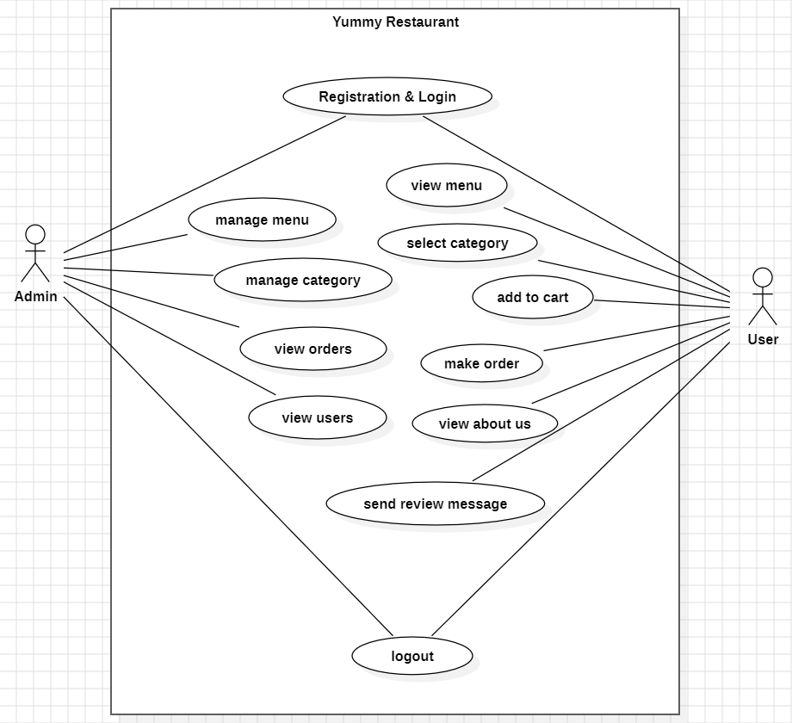Figure(3.1) Use Case Diagram of the System

Figure(3.1) shows the Yummy Restaurant system depicts interactions between two actors, **Admin** and **User**, across several modules. The **Admin** has controled over the system, managing menus, categories, orders, and users, while the **User** can view the menu, select categories, add items to the cart, place orders, and send review messages. Both actors share access to the registration, login, and logout functions. The diagram effectively illustrates how each actor interacts with specific functionalities within the system, emphasizing the admin’s role in managing content and the user’s focus on ordering and reviewing.

**3.1.1 Use Case Diagram for the Admin**

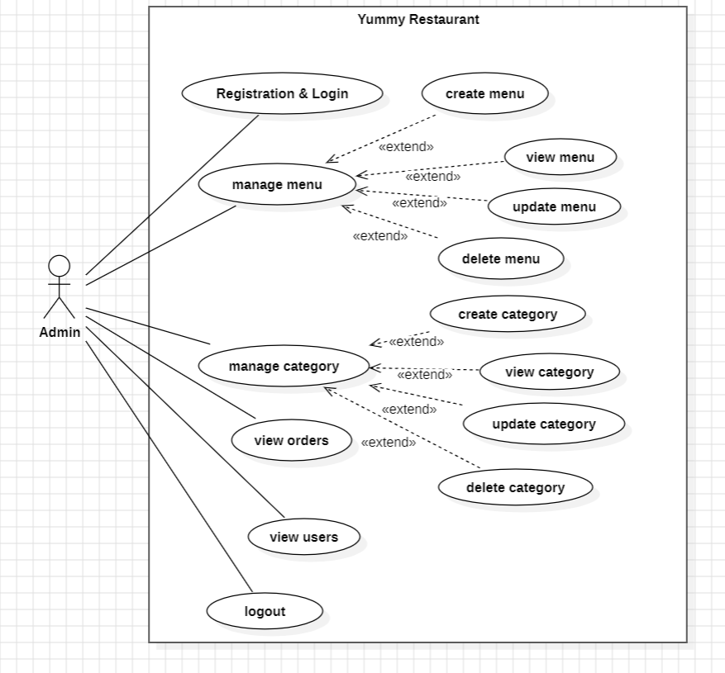Figure(3.1.1) Use Case Diagram for the admin

Figure (3.1.1) depicts the use case diagram that outlines the activities of the admin within the Yummy Restaurant system. Upon signing into the system, the admin is first validated by the backend. If the credentials are correct, the admin gains access to the system's functionalities.The admin can **manage the menu** by adding, updating, or deleting menu items through the admin panel. Additionally, the admin can organize the menu by managing **categories**, which involves creating, updating, or removing categories. The admin is also responsible for handling **orders** submitted by users, which includes viewing the details and confirming the orders. Furthermore, the admin can view the list of registered **users** within the system and manage additional services, such as creating and updating extra offerings that can be associated with the restaurant’s menu.

**3.1.2 Use Case Diagram for the User**

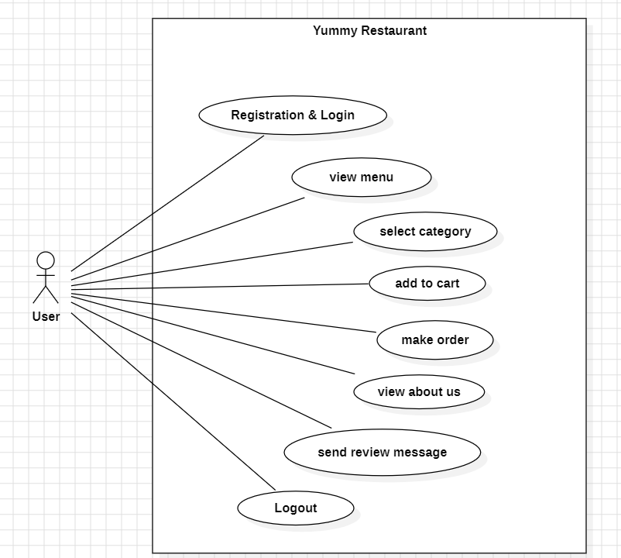Figure(3.1.2) Use Case Diagram for the user

Figure (3.1.2) presents the use case diagram for the user's experience on the Yummy Restaurant website. The image depicts a use case diagram for the "Yummy Restaurant" system, illustrating the interactions between a user and the system. The user can perform various actions such as registration and login, viewing the menu, selecting a category, adding items to the cart, making an order, viewing information about the restaurant, sending a review message, and logging out. Each of these actions represents a different use case within the system, demonstrating the core functionalities that the restaurant's online platform offers to its users.

**3.2 ER Diagram of the system**

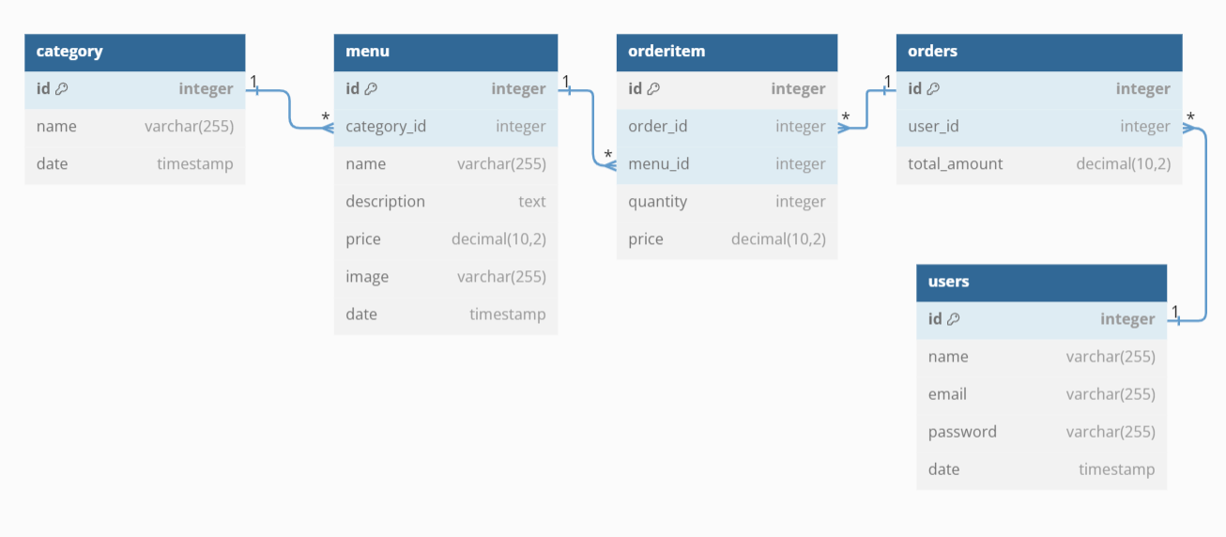

Figure(3.2) ER Diagram of the system

In Figure(3.2), the ER (Entity Relationship) Diagram is shown. The Restaurant Management System's entity-relationship diagram illustrates all of the database tables and their relationships. The connections between entities such as `users`, `menu`, `category`, `orders`and `orderitem` are clearly depicted. The ER diagram of the system represents the data structure and the supposed database design of the project. This diagram conveys the data that would be managed within the restaurant management system, its attributes, and its relationships with other data (entities).The relationships between these entities are crucial for the functioning of the restaurant management system, ensuring that users can browse the menu, add items to their cart, place orders, and the system can track and manage these activities efficiently.

**3.3 System Flow Diagram for Login and Register**

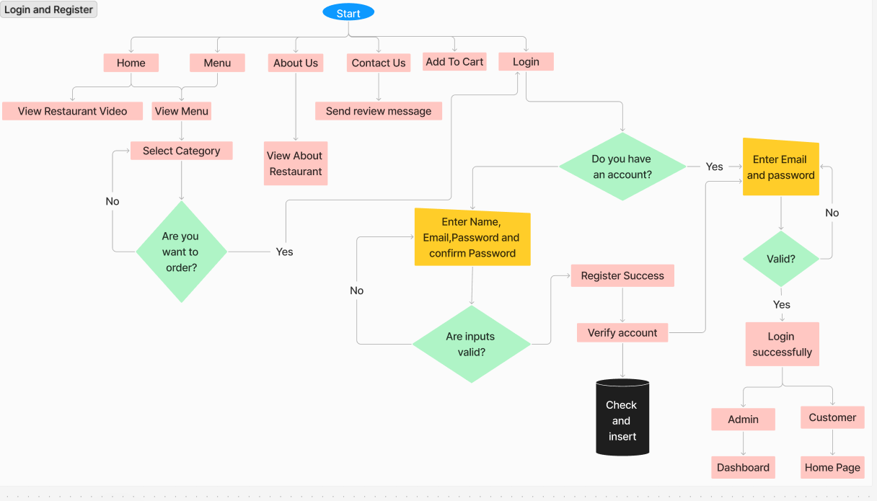Figure(3.3)System Flow Diagram for Login and Register

The flowchart illustrates the process flow for accessing the Yummy Restaurant system without logging in. When a user visits the platform without authentication, they are granted read-only access to explore various sections of the system. This includes browsing the menu, viewing available dishes, and exploring other public pages like the About, Contact Us, and Gallery sections. However, any actions requiring user authentication, such as placing an order or accessing personal account details, are restricted and prompt the user to log in or register.

**3.3.1 System Flow Diagram for the System**

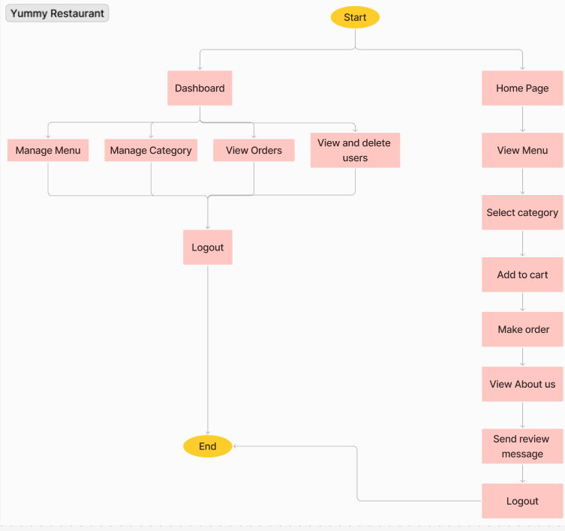Figure(3.3.1)System Flow Diagram for the System

The flowchart depicts the process flow for users who have logged into the Yummy Restaurant website. Once logged in, users can access the Dashboard, where they have the ability to manage various aspects such as the menu, categories, and orders, as well as view and delete user accounts. On the customer side, logged-in users can browse the Home Page, select menu items, add them to the cart, and proceed to place an order. Additional features available include viewing the "About Us" page, sending review messages, and logging out of the system. This streamlined flow ensures that both administrative tasks and customer activities are efficiently managed within the website.

**3.4 Theory Background of the System**

In software development, various models exist, each offering distinct benefits and drawbacks. For the development of this system, the Waterfall Model was chosen.

**3.4.1 Waterfall Model**

The Waterfall Model, introduced by Winston Royce in 1970, follows a linear and sequential approach to software development. It consists of five key phases: requirements analysis and specification, design, implementation and unit testing, integration and system testing, and operation and maintenance. These phases are executed in a strict order, with each phase needing to be completed before the next one begins. The model is called the "Waterfall Model" because, like a series of waterfalls, each phase flows into the next without overlapping.

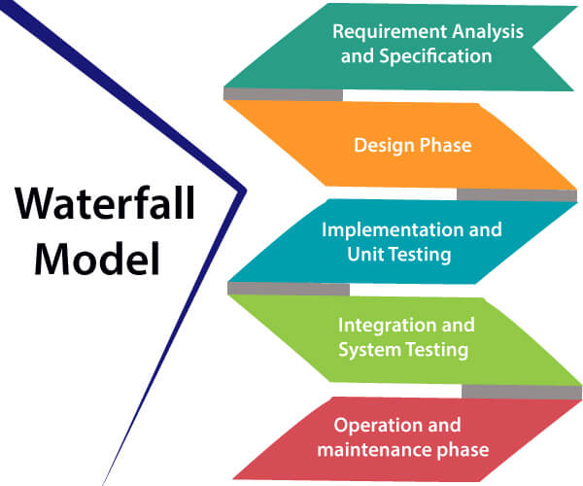

Figure(3.4.1) Waterfall Model

1. Requirements analysis and specification phase: This initial phase focuses on understanding the customer's exact needs and documenting them thoroughly. The customer collaborates with the software developer to detail all functional, performance, and interface requirements. The outcome is a comprehensive document known as the Software Requirement Specification (SRS), which describes "what" the system is intended to do in clear, non-technical language.
2. Design Phase: This phase aims to transform the requirements gathered in the SRS into a suitable form which permits further coding in a programming language. It defines the overall software architecture together with high level and detailed design. All this work is documented as a Software Design Document (SDD).
3. Implementation and unit testing: During implementation, the design is translated into code. If the SDD is well-prepared, this phase proceeds smoothly as developers have all the necessary information. Unit testing is also performed at this stage, where indicidual modules are tested in isolation and then intefrated to ensure they work together as expected.Integration and System Testing:This phase is highly crucial as the quality of the end product is determined by the effectiveness of the testing carried out. The better output will lead to satisfied customers, the lower maintenance costs, and accurate results. Unit testing determines the efficiency of individual modules. However, in this phase, the modules are tested for their interactions with each other and with the system.
4. **Integration and System Testing:** This phase is crucial for ensuring the quality of the final product. Modules are tested together to verify their interactions and the overall functionality of the system. Effective testing at this stage leads to a product that meets customer expectations, has lower maintenance costs, and delivers accurate results.
5. Operation and maintenance phase: Maintenance is the task performed by every user once the software has been delivered to the customer, installed, and operational.

**3.5 Technology Background of the System**

**3.5.1 HTML**

HTML, or Hyper Text Markup Language, is the standard language for creating web pages. It’s not a programming language but a markup language, meaning it uses tags to structure and display content on the web. Hypertext refers to the ability to link web pages to one another, allowing users to navigate the web seamlessly.

**3.5.2 CSS**

Cascading Style Sheets (CSS) is a styling language used to define the appearance of web pages. CSS allows developers to control layout, colors, fonts, and spacing, making it a powerful tool for creating visually appealing websites.

**3.5.3 JavaScript**

JavaScript is a scripting language designed to add interactivity to web pages. It’s a lightweight, interpreted language that runs in the browser, allowing for dynamic content, such as interactive forms, animations, and real-time updates, without requiring a page refresh.

**3.5.4 Bootstrap**

Bootstrap is a popular front-end framework that simplifies web development. It provides pre-designed HTML and CSS templates for common interface components like forms, buttons, navigation, and modals, along with optional JavaScript plugins to enhance functionality.

**3.5.5 PHP**

PHP (Hypertext Preprocessor) is a server-side scripting language used to create dynamic web content. As an open-source language, PHP is widely used for its flexibility and compatibility with various databases, including MySQL.

**3.5.6 MYSQL**

MySQL is a widely-used relational database management system (RDBMS). It is known for its reliability, ease of use, and ability to handle large volumes of data efficiently. MySQL uses structured query language (SQL) to manage data stored in a database.

**3.5.7 JQUERY**

jQuery is a fast, small, and feature-rich JavaScript library that simplifies the process of adding interactivity to web pages. It provides a simple syntax for event handling, animations, and AJAX interactions, while also addressing cross-browser compatibility issues.

**3.5.8 System Requirements**

To develop the Yummy Restaurant web application, a standard PC configuration is required.

**3.5.9 Software Requirements**

For the development environment, Windows 7 or later is recommended for its stability and feature set. MySQL is used as the database system due to its ease of use and powerful querying capabilities. The web pages are built using HTML, styled with CSS and JavaScript, and dynamic content is managed with PHP.

**3.5.10 Hardware Requirements**

Any requirement is available but Intel core i5 7th generation is used as a processor because it is faster than other processors provides reliability and stable and pc can be run for longtime.

**CHAPTER 4**

**SYSTEM IMPLEMENTATION**

This chapter describes the steps involved in implementing the project.

**4.1 Register for the Admin and User**

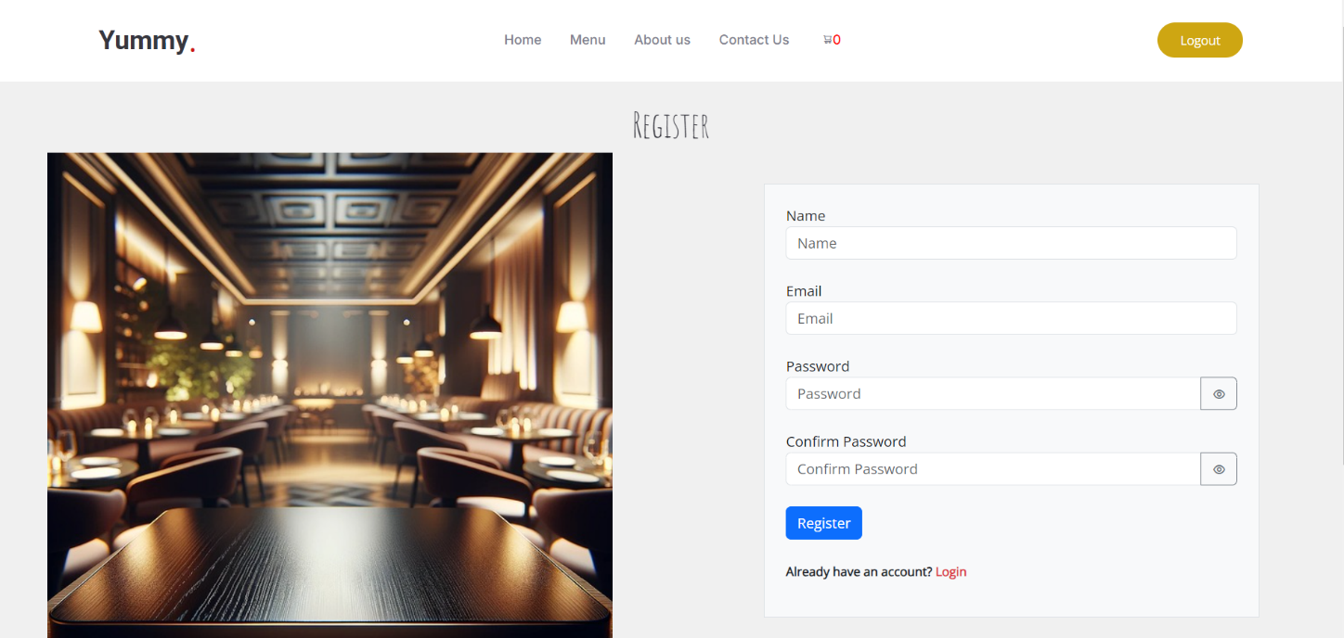

Figure (4.1) Register for Admin and User

Figure (4.1) shows that a registration system is created for both admin and user roles, this form should include fields for username, email, password, and confirm password. The username will uniquely identify each user or admin. The email will be used for communication and login purposes. The password field ensures that the user's account is secure, while the confirm password field helps to verify the accuracy of the entered password, preventing any typos or mistakes during the registration process. This system will allow seamless registration for both regular users and admins, differentiating their roles based on their privileges within the platform.

**4.2 Login for the Admin and User**

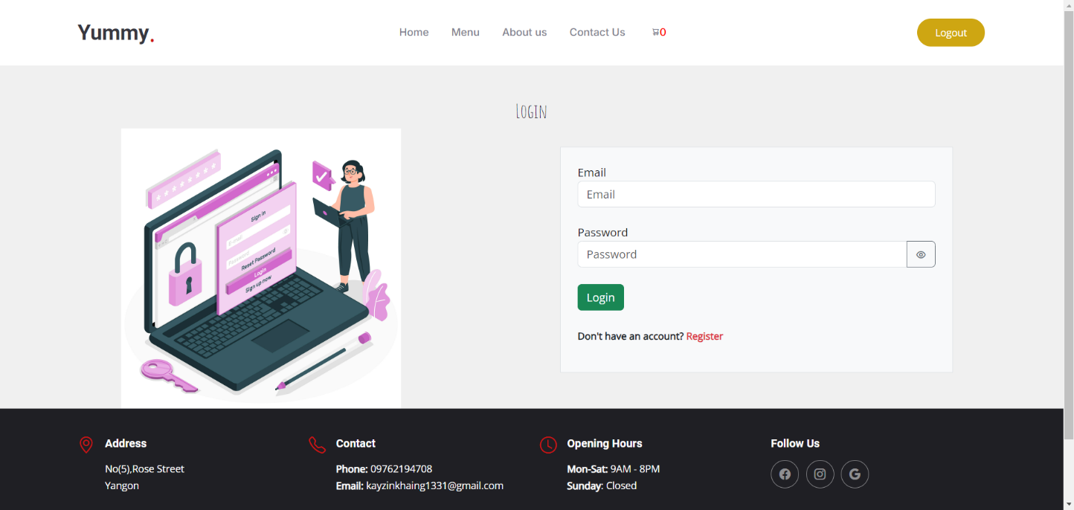

Figure (4.2) Login for Admin and User

Figure (4.2) shows that a login system is implemented for both admin and user roles, an email and password for authentication. Each user will have a role assigned in the database: `0` for regular users and `1` for admins. Upon successful login, the system checks the user's role. If the role is `1`, the user is redirected to the admin dashboard, allowing them to manage the restaurant system. If the role is `0`, the user is redirected to the main website, where they can browse the menu, place orders, and interact with the site as a customer. Admins can only access the admin dashboard if their role is set to `1` in the database, ensuring that only authorized personnel can manage the system.

**4.3 The Admin Dashboard**

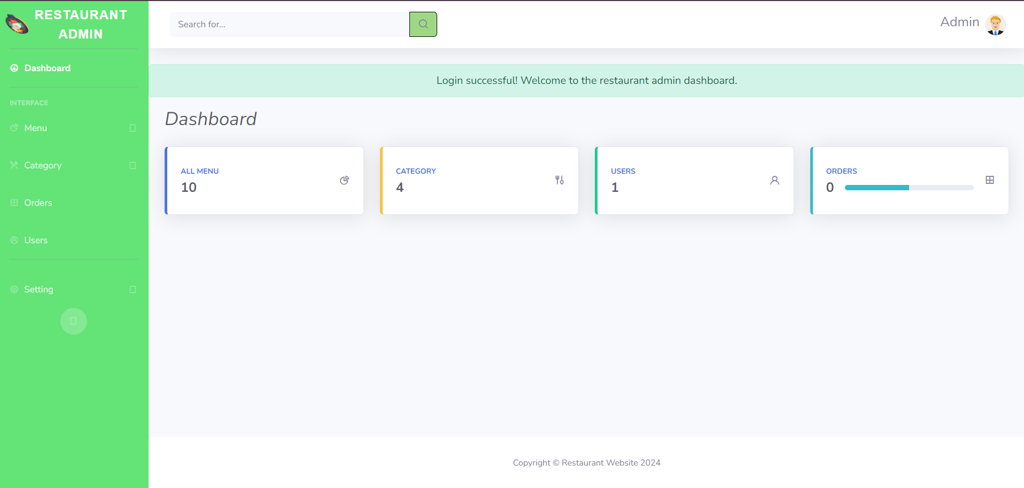Figure (4.3) The Admin Dashboard Layout

Upon login, the admin can easily view counts and perform tasks like adding or updating menu items and processing orders.

**4.4 View Menu**

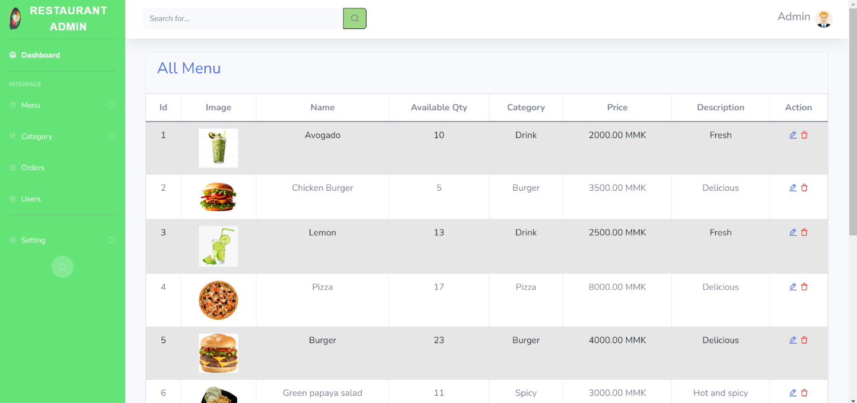Figure (4.4) View Menu

In the View Menu section, admins can quickly access detailed info on each menu item, including images, names, quantity, category, price, and descriptions. They can also easily edit or delete items for streamlined menu management.

**4.5 Add Menu**

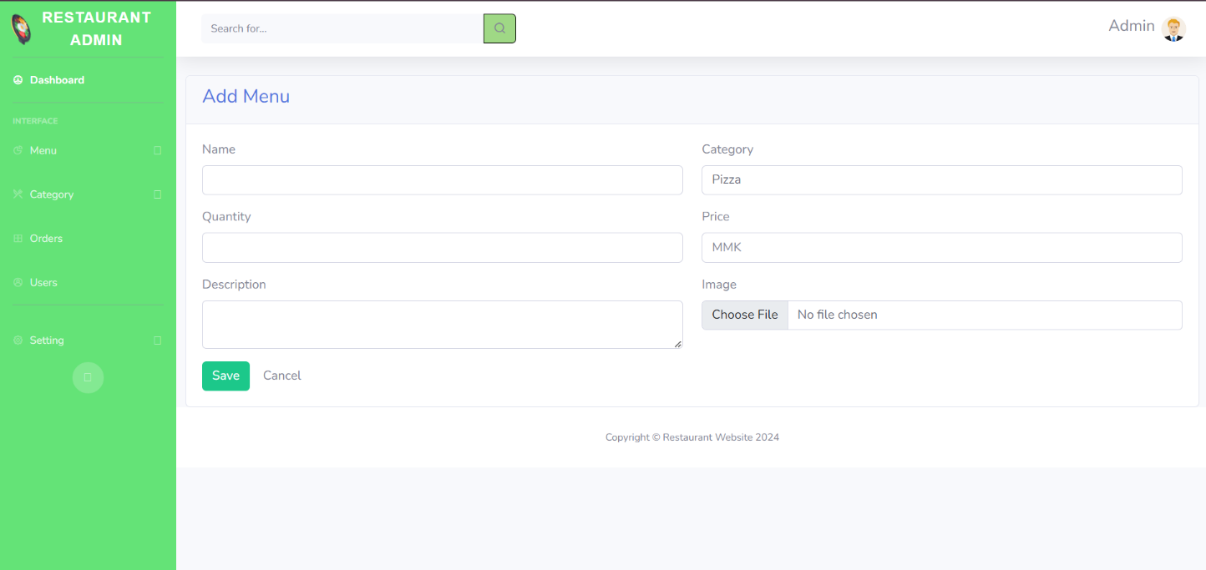Figure (4.5) Add Menu

In the **Add Menu** functionality of the Yummy Restaurant system, the admin can create new menu items by entering details such as the image, name, available quantity, category, price, and description. This allows for easy management and organization of the restaurant's offerings.

**4.6 View Category**

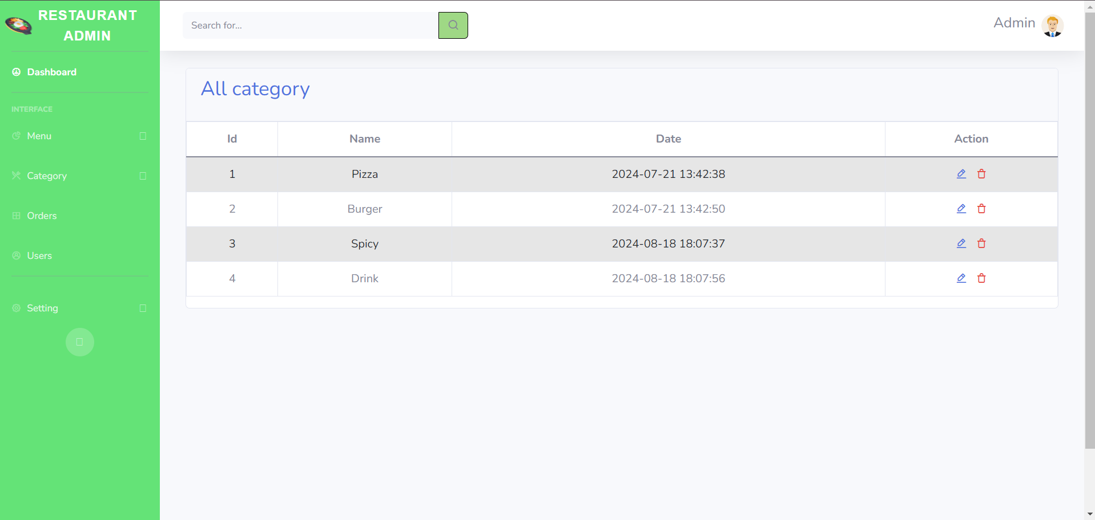Figure (4.6) View Category

In the **View Category** section, admins can see the category name and the date that was added or last modified. They also have the ability to edit or delete categories directly from this view.

**4.7 Add Category**

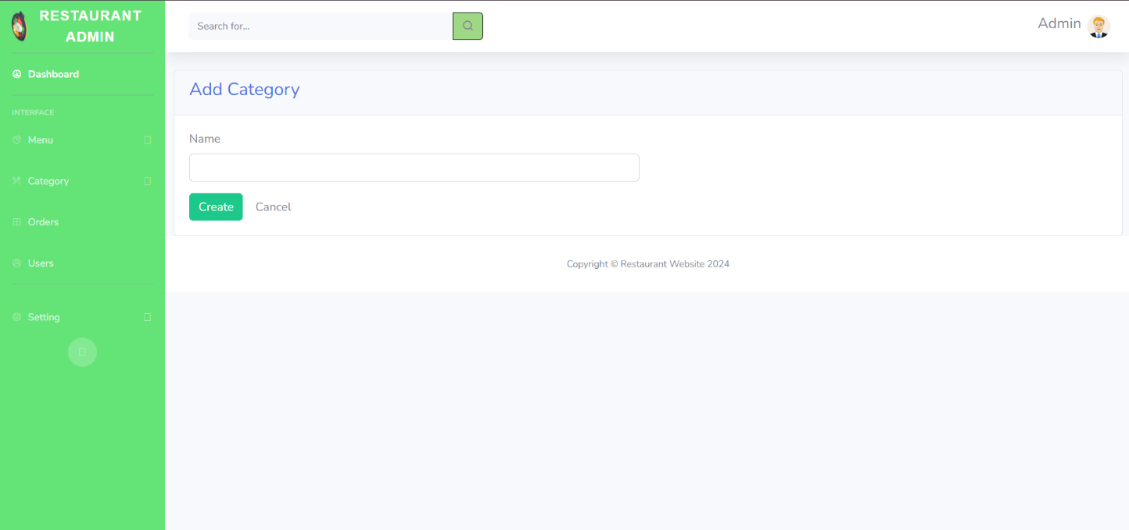Figure (4.7) Add Category

When adding a category name in the view category section, the system checks if the entered name already exists in the database. If it does, an error message "Category already exists" is displayed, preventing duplicate entries. This ensures that each category remains unique and avoids any potential confusion or redundancy.

**4.8 View Orders**

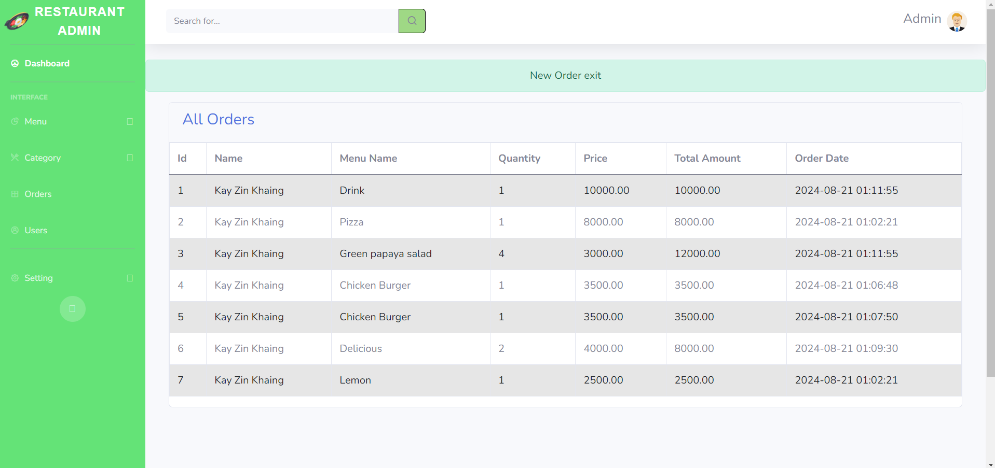Figure (4.8)View Orders

In the view order section, the admin can see detailed information for each order, including the customer’s Name, the selected Menu Name, Quantity, Price, Total Amount, and Order Date. This allows for efficient tracking and management of all orders based on the specific menu items chosen by users.

**4.9 View Users**

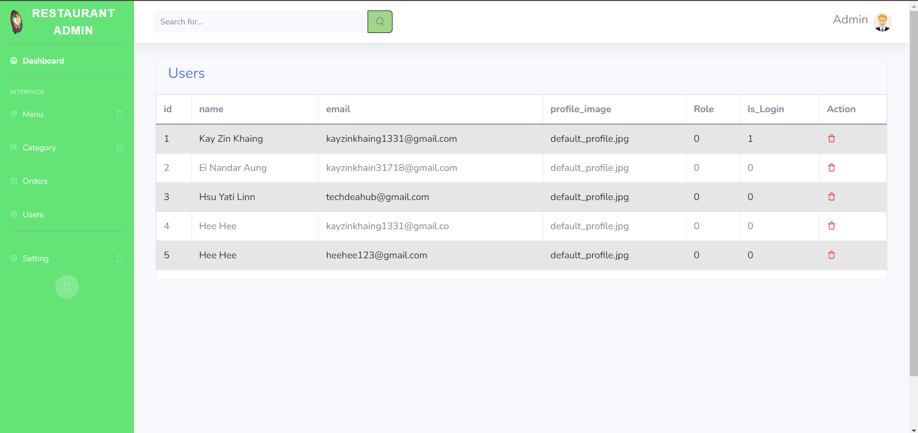Figure (4.9)View Users

In the users section, the admin can manage accounts by viewing details like Name, Email, Profile Image, Role, and Login Status. Roles are labeled as user (0) or admin (1), and the Login Status shows if a user is logged in (1) or not (0). Admins can also delete users from this interface.

**4.10 User Home Page**

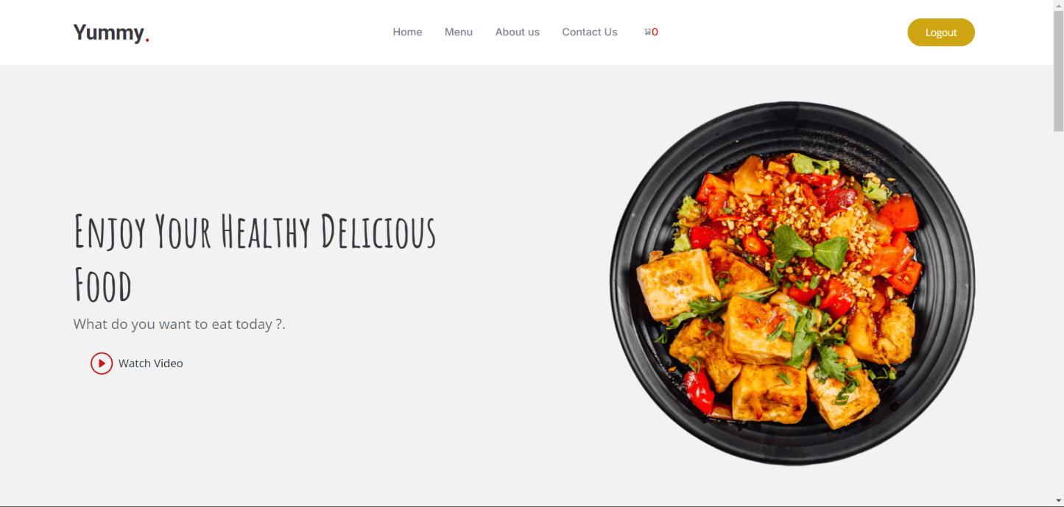Figure (4.10) User Home Page

On the user home page of the Yummy Restaurant system, visitors can watch an engaging video introducing the restaurant. The page also provides easy navigation with links to Home, Menu, About, and Contact sections, offering a seamless and informative user experience.

**4.11 Random Menu in Home Page**

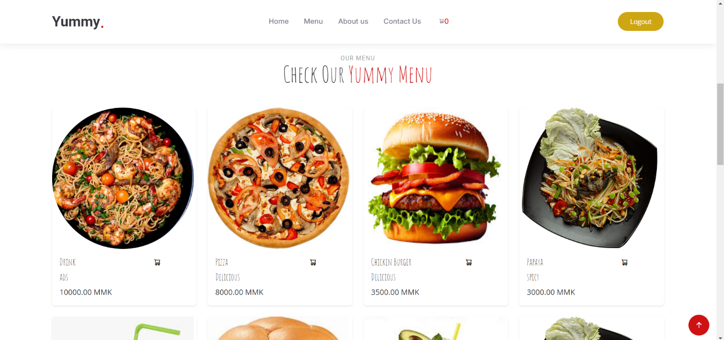

Figure (4.11) Random Menu in Home Page

On the home page, a selection of eight random menu items is displayed to give visitors a glimpse of the diverse offerings at Yummy Restaurant. This dynamic feature showcases different dishes each time, enticing users to explore the full menu.

**4.12 View Gallery and Why Choose Menu**

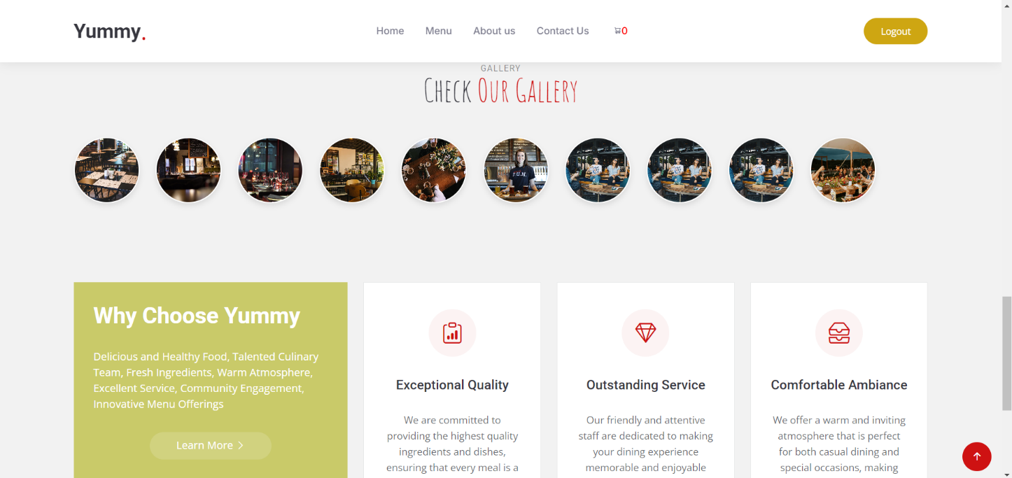Figure (4.12) View Gallery and Why Choose Menu

In the View Gallery section, users can browse lively photos showcasing Yummy Restaurant’s atmosphere. “The Why Choose Us section” emphasizes the restaurant’s dedication to top-quality food, excellent service, and a cozy setting, making Yummy an ideal dining spot.

**4.13 Menu Page**

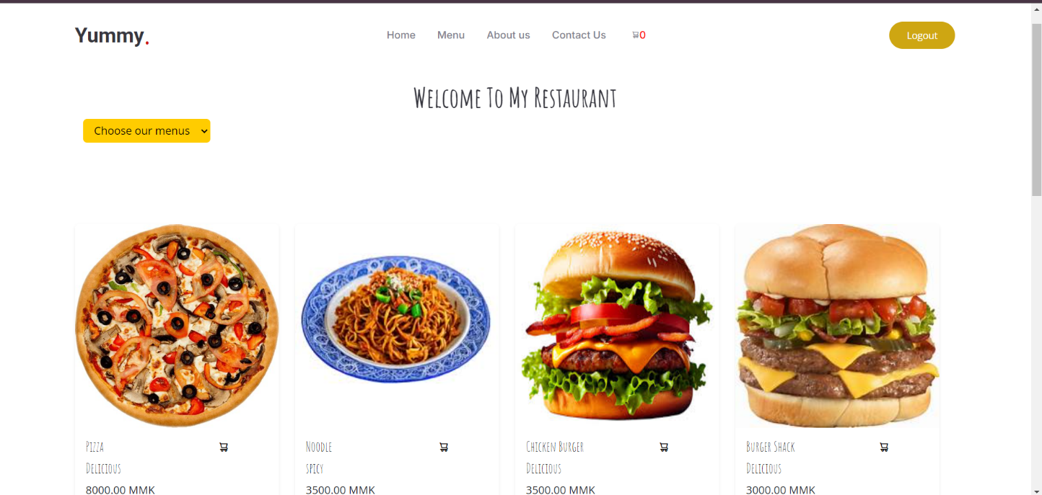Figure (4.13) Menu Page

On the menu page, users can browse the entire menu and filter items by their preferred category. They can view detailed information about each dish and add items to their cart, with the ability to select based on the available quantity provided by the admin.

**4.14 About Page**

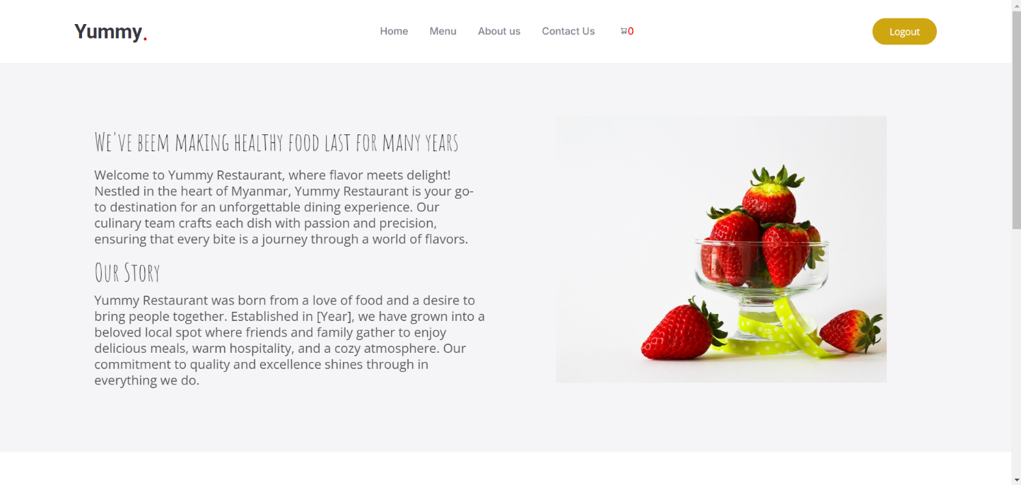Figure (4.14) About Page

On the About page, visitors can learn more about Yummy Restaurant, including its history, mission, and values. This section provides insights into what makes the restaurant special and highlights its commitment to delivering exceptional dining experiences.

**4.15 Contact Us Page**

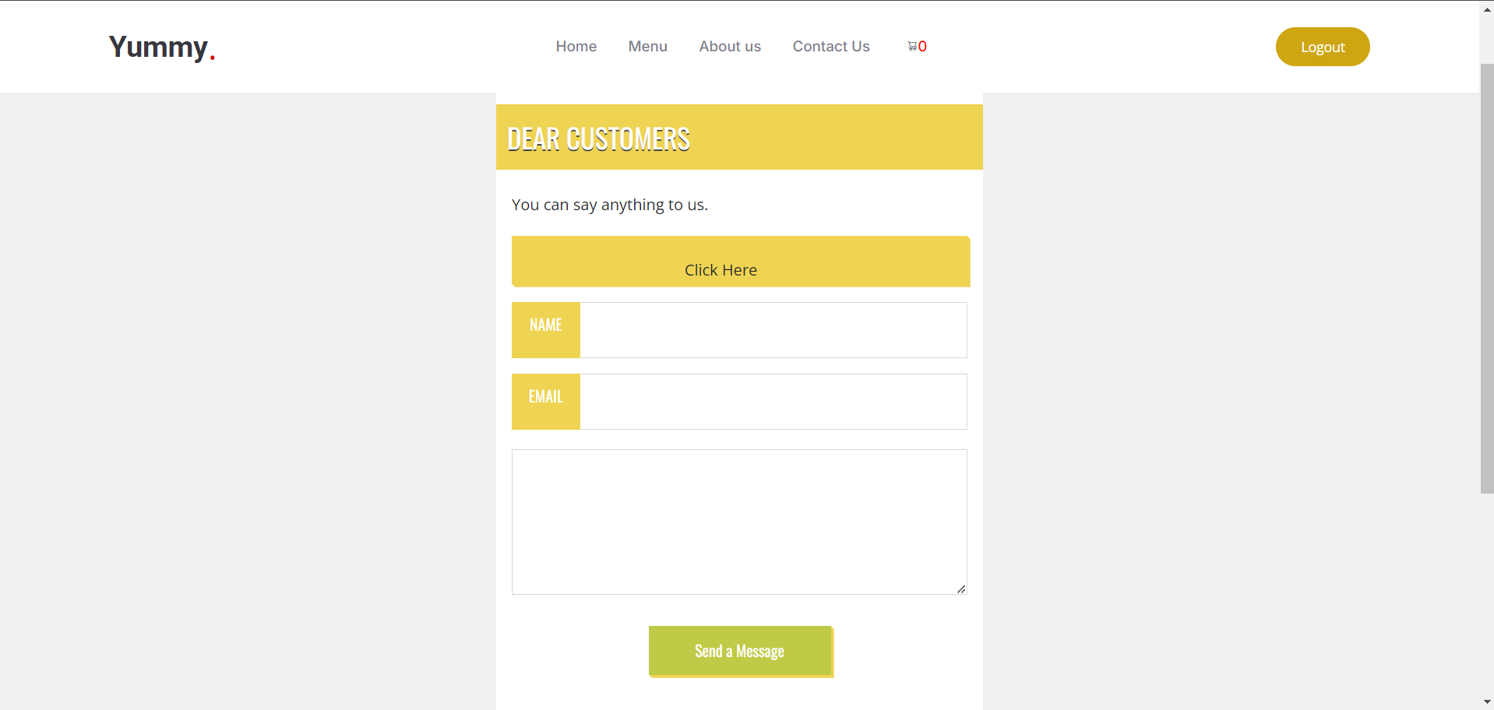Figure (4.15) Contact Us Page

Figure(4.15),the Contact page allows users to quickly email the admin with issues or feedback about Yummy Restaurant, ensuring direct communication for timely responses.

**4.16 Add to cart**

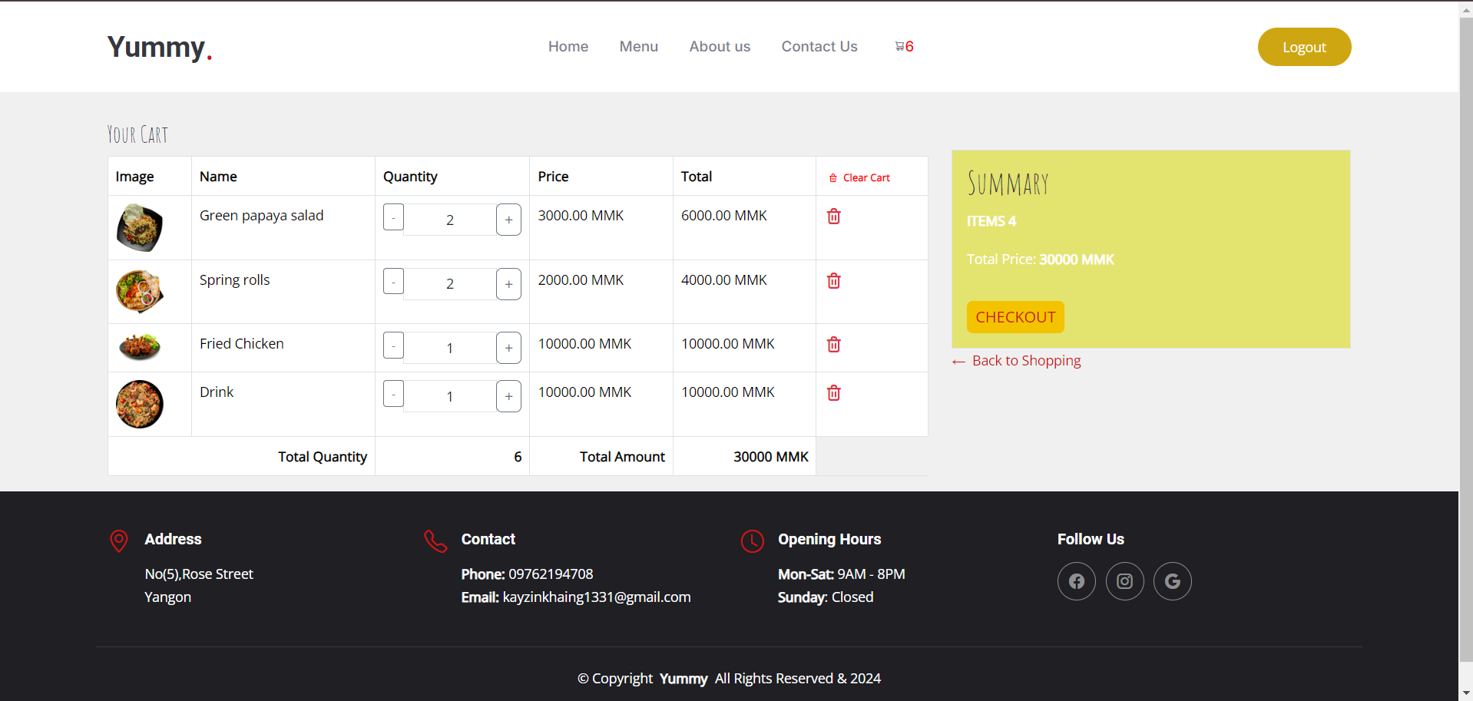Figure (4.16) Add to cart

On the Add to Cart page, users can view selected items with their images, names, quantities, and prices, and see the total amount. They can adjust quantities, delete individual items, or clear the entire cart. If they wish to continue shopping, they can go back, or proceed to checkout to finalize their order.

**4.17 Your Order Cart**

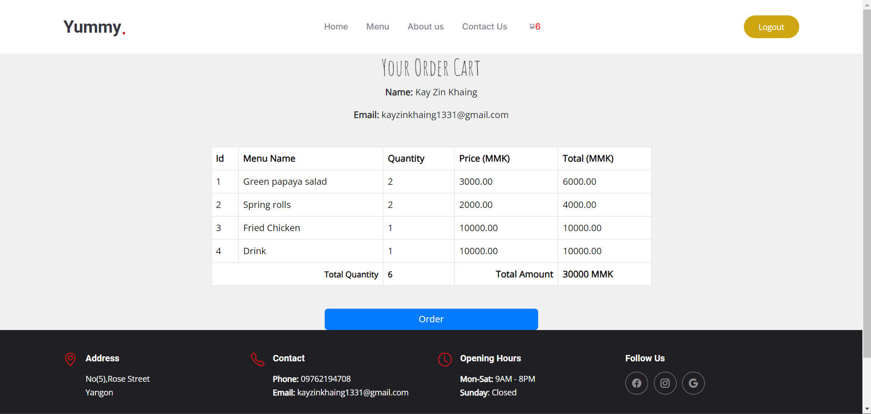Figure (4.17) Your Order Cart

On the Order Cart page, users can review their selected items and quantities before placing an order. They can proceed to checkout to finalize their purchase or send the order details to the admin for processing.

**4.18 Success for order**

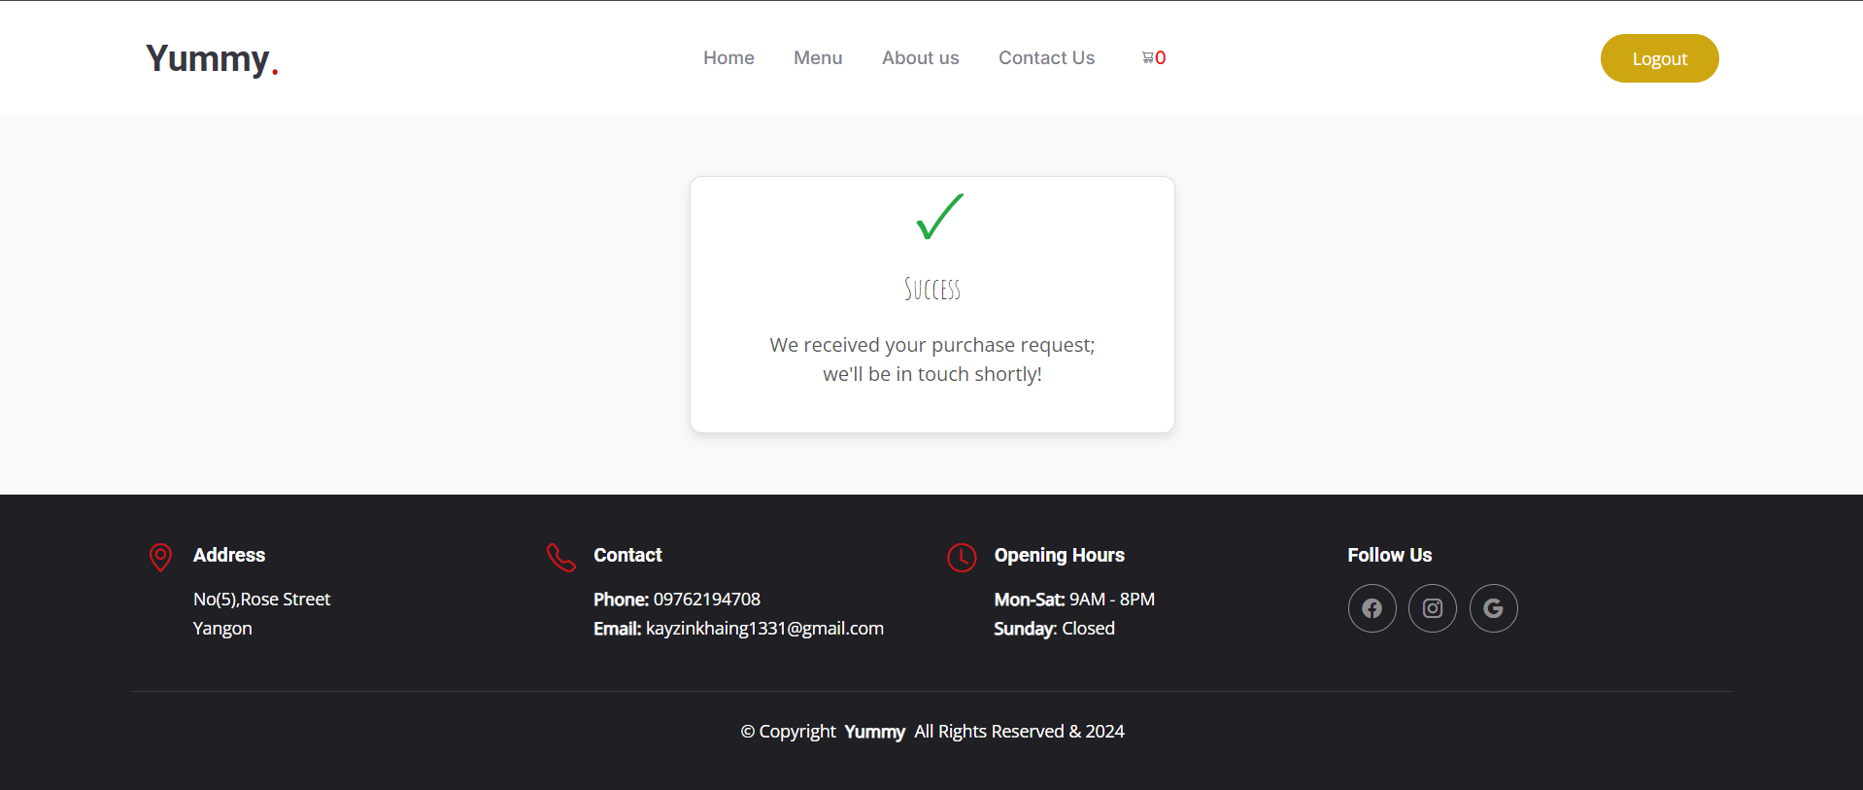

Figure (4.18) Success for order

After placing an order, users will see a confirmation message indicating that their order has been successfully received. This page reassures them that their request is being processed and provides a sense of completion and satisfaction.

**CHAPTER 5**

**CONCLUSION**

The programming skills and theories learned at the university were put into practice during three-month internship at the Camp. It is need to manage time more effectively, handle issues with greater social acumen, and apply a variety of solutions to overcome challenges in achieving the goals. This internship was both an excellent and rewarding experience, enriching the IT knowledge, programming skills, and understanding of what is required in the IT field. Throughout the internship, valuable experience and knowledge are gained in programming, communication, English language skills, and IT concepts, all of which will be beneficial for the future career.In this internship report, implementing the proposed idea is envisioned as a crucial role. The project worked on is titled “Yummy Restaurant.” The objective of the proposed system is to deliver an exceptional dining experience by combining high-quality ingredients, outstanding service, and a welcoming atmosphere. Yummy Restaurant offers a diverse menu that caters to various tastes and preferences, allowing customers to explore a wide range of dishes in a comfortable and inviting setting. The user-friendly online platform makes it easy for guests to navigate, view the menu, filter by categories, and effortlessly add their favorite items to the cart. Whether dining in or ordering online, Yummy Restaurant ensures a seamless and enjoyable experience from start to finish. The commitment to excellence is evident in every aspect of the service, from the carefully curated menu to the attentive staff who are always ready to assist. Everyone is invited you to experience the best in dining and hospitality at Yummy Restaurant, where every meal is crafted with care and every visit is memorable.

## RECOMMENDATION

Through this internship, I recognized the gap between academia and industry and gained valuable real-world experience. I developed skills and techniques directly relevant to my career, enhanced my communication abilities, and deepened my understanding of web design and development. This experience also allowed me to apply the theories I learned in the university to real-world scenarios. Additionally, I acquired both technical and soft skills, such as effective communication and reporting, essential for becoming a professional developer.

**5.1 Short-term Recommendations**

During the time at ITVisionHub, I was highly satisfied with the internship experience. The program is instrumental in providing students with practical and analytical skills, particularly in PHP development. This opportunity has been invaluable for gaining new knowledge, ideas, and experience that extend beyond the university environment.

**5.2 Long-term Recommendations**

The internship allowed me to hone my communication, technical, and time management skills. I learned the importance of adhering to company rules and regulations and gained significant knowledge and experience in the process. It is crucial for students to focus on practical skills during their academic studies. Those learning programming should continuously improve their knowledge to succeed in their careers.

## REFERENCES

1. https://bootstrapmade.com/yummy-bootstrap-restaurant-website-template
2. W3Schools. Retrieved from <https://www.w3schools.com>
3. Google Search Engine. Retrieved from <https://www.google.co.in>